

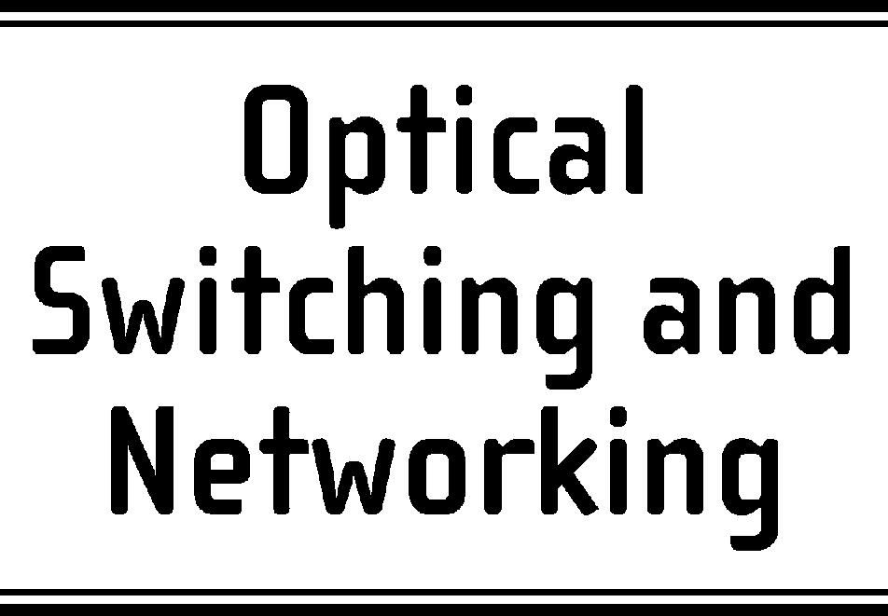

Optical Switching and Networking 3 (2006) 202–218

www.elsevier.com/locate/osn

Optimized design of survivable MPLS over optical transport
networks

Wojtek Bigosª, Bernard Cousin^{b}, Stґephane Gosselinª, Morgane Le Follª,
Hisao Nakajimaª,∗

a France Tґelґecom R&D – CORE/MCN, Lannion, France
b University of Rennes 1, IRISA Research Laboratory, Rennes, France
Received 14 June 2005; received in revised form 29 July 2006; accepted 14 August 2006
Available online 26 September 2006

Abstract

In this paper we study different options for the survivability implementation in MPLS over Optical Transport Networks (OTNs)
in terms of network resource usage and conﬁguration cost. We investigate two approaches to the survivability deployment: single-
layer survivability, where some recovery mechanism (e.g. protection or restoration) is implemented in a single network layer and
multilayer survivability, where recovery is implemented in multiple network layers. The survivable MPLS over OTN design is
implemented as a static network optimization problem and incorporates various methods for spare capacity allocation (SCA) to
reroute disrupted trafﬁc.
The comparative analysis between the single layer and the multilayer survivability shows the inﬂuence of the trafﬁc granularity
on the survivability cost: for high-bandwidth LSPs, close to the optical channel capacity, the multilayer survivability outperforms
the single layer one, whereas for low-bandwidth LSPs the single-layer survivability is more cost-efﬁcient. For the multilayer
survivability we demonstrate that by mapping efﬁciently the spare capacity of the MPLS layer onto the resources of the optical
layer one can achieve up to 22% savings in the total conﬁguration cost and up to 37% in the optical layer cost. Further savings (up to
9%) in the wavelength use can be obtained with the integrated approach to network conﬁguration over the sequential one; however,
this is at the increase in the optimization problem complexity. These results are based on a cost model with current technology
pricing and were obtained for networks targeted to a nationwide coverage.
c 2006 Elsevier B.V. All rights reserved.

Keywords: MPLS over OTN; Multilayer network design; Multilayer routing; Survivability design; Spare capacity allocation

1. Introduction
The considered MPLS over an Optical Transport
Network (OTN) represents a multilayer network

∗ Corresponding author. Tel.: +33 2 96 05 38 26; fax: +33 2 96 05
12 52.
E-mail addresses: wojtek.bigos@francetelecom.com (W. Bigos),
Bernard.Cousin@irisa.fr (B. Cousin),
stephane.gosselin@francetelecom.com (S. Gosselin),
morgane.lefoll@francetelecom.com (M. Le Foll),
hisao.nakajima@francetelecom.com (H. Nakajima).

1573-4277/$ - see front matter c 2006 Elsevier B.V. All rights reserved.
doi:10.1016/j.osn.2006.08.001

architecture, where label switching routers (LSRs)
making up the MPLS layer are directly attached to
optical cross-connects (OXCs) belonging to the optical
layer. In the optical layer, optical cross-connects are
interconnected with point-to-point WDM links in a
mesh topology. The interconnection between routers in
this architecture is provided by circuit-switched, end-
to-end optical channels or lightpaths [1]. A lightpath
(LP) represents a sequence of ﬁber links forming a path

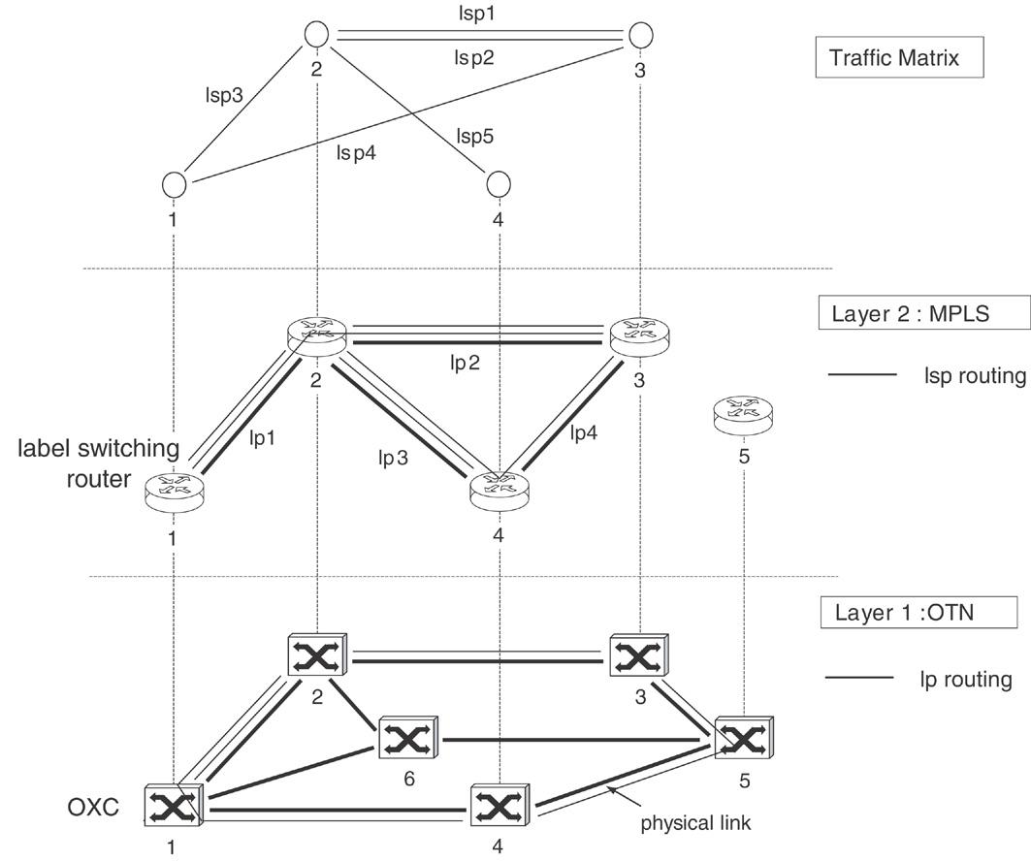
W. Bigos et al. / Optical Switching and Networking 3 (2006) 202–218

Fig. 1. MPLS over OTN architecture model (lsp — label switched path, lp — lightpath).

203

from a source to a destination router together with a
single wavelength on each of these links. The OXCs
can switch wavelengths between ﬁber links without
undergoing optoelectronic conversion. A lightpath must
be assigned the same wavelength on each link on
its route, unless the OXCs support the wavelength
conversion capability. The set of lightpaths established
in the network makes up a logical network topology.
The IP trafﬁc in the form of label switched paths (LSPs)
is carried in the network over this logical topology using
single or multiple logical hops. Fig. 1 shows an example
of the MPLS over OTN.
As network survivability plays a critical role in
the network design, a number of recovery schemes
have been proposed in the scope of the MPLS
over OTN architecture. They are based on two
general concepts: single-layer survivability [2,3], where
recovery mechanisms are implemented only in the
MPLS layer, and multilayer survivability [2,4,5], where
recovery is employed both in the MPLS and the optical
layer. The multilayer survivability has the advantage
over the single-layer approach in faster and simpler
recovery from physical link failures but it is considered

to consume more optical layer resources [2,4]. This is
because with the multilayer recovery each network layer
reserves some spare resources for rerouting of affected
paths, so multiple spare capacity pools are provided,
each dedicated to a particular layer. On the other hand,
single-layer recovery requires more resources from the
MPLS layer which may negatively affect the total
network conﬁguration cost as, according to the current
technology pricing, these resources are more expensive
than the resources of the optical layer.
In this paper we present the design of a survivable
MPLS over an Optical Transport Network (OTN) as
an integer linear programming (ILP) optimization prob-
lem. Our objective is to minimize the amount of net-
work resources used with a given network conﬁgura-
tion. There are implemented different methods for spare
capacity allocation (SCA) with single-layer and multi-
layer survivability to reroute disrupted trafﬁc. The plan-
ning process for SCA is based on two approaches to
the MPLS over OTN conﬁguration: the sequential one,
where the MPLS layer and the optical layer are planned
separately, and the integrated one, where the whole
network is designed in one step. The aspects of spare

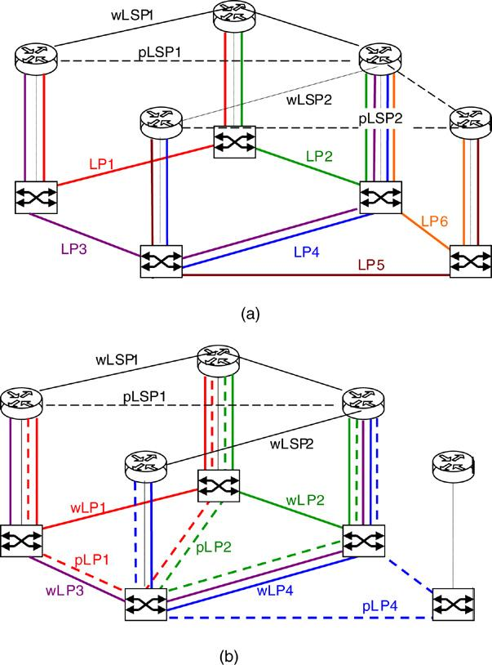
204

W. Bigos et al. / Optical Switching and Networking 3 (2006) 202–218

capacity planning and sequential/integrated approaches
to network conﬁguration are related to the design of
multilayer network architectures and contribute to ef-
ﬁcient network conﬁguration in terms of resources us-
age. The objective of this work is to consider both these
aspects in the context of network optimization and to
investigate their impact on network resource savings. A
set of MPLS over OTN conﬁgurations is implemented,
where a particular SCA method is combined with a par-
ticular conﬁguration approach demonstrating their rela-
tive importance to the overall network design in terms of
network resource consumption and conﬁguration cost.
The rest of this paper is organized as follows.
Section 2 presents different SCA methods for the
single- and the multilayer survivability implementation.
Section 3 describes two approaches to the MPLS over
OTN design: sequential and integrated, and explains
their impact on the network resource usage. We precise
the objectives to be realized with respect to these
problems and explain how our work extends the
previous studies. In Section 4 we deﬁne a framework
for the survivable MPLS over OTN design. We present
algorithms for different spare capacity planning options,
deﬁne a cost model to be included into the optimization
procedure and give exact ILP formulations for the
considered problems. Section 5 concludes with the
analysis of the obtained results.

2. Spare capacity planning in MPLS over OTN

One of the aspects related to the survivability
design is how to allocate spare capacity in a network,
so that the total amount of network resources is
minimized. The total amount of network resources
used with a given SCA option depends on supported
failure scenarios and the recovery technique used.
Although many recovery schemes can be employed
in individual layers of the MPLS over OTN model
(e.g. protection vs. restoration, dedicated vs. shared,
end-to-end vs. local), we focus here on the multilayer
aspects of the survivability design, leaving the problem
of the survivability deployment in individual network
layers out of consideration. Therefore, only one (and
the same) recovery technique is assumed in individual
network layers, which is end-to-end path protection
both with dedicated and shared spare capacity. It is
believed that such a recovery scheme will be always
required in the network to protect the integrity of high-
class services. The considered failure scenarios include
physical link failures (e.g. ﬁber cuts, optical line system

Fig. 2. Two options for the survivability implementation in MPLS
over OTN: (a) single-layer survivability (b) multilayer survivability
(w/pLSP — working/protection LSP, w/pLP — working/protection
lightpath).
failures), transit¹node failures (both router and OXC)
and IP/optical interface failures.
With the single-layer survivability (Fig. 2(a))
protection is implemented at the LSP level and the
MPLS layer covers all failure types. Each working LSP
(wLSP) has a corresponding protection LSP (pLSP),
link- and node-disjoint in both network layers. With
the multilayer survivability (Fig. 2(b)) protection is
implemented both at the LSP level (pLSP) and the
lightpath level (pLP). The optical layer protects against
physical link and OXC failures, whereas the MPLS
layer protects against router and IP/optical interface
failures which cannot be detected by the optical layer.
The MPLS layer also protects against OXC failures
with respect to the LSPs’ transit in co-located routers.
This implies that, with the multilayer survivability,
only multi-hop LSPs which are susceptible to router
failures have corresponding protection LSPs routed in
the MPLS layer (to provide node-disjointness against
router failures). Single-hop LSPs do not require any

1 Paths originating/terminating at a failed node are considered as
lost since they cannot be restored with path protection mechanisms.

W. Bigos et al. / Optical Switching and Networking 3 (2006) 202–218

205

extra spare capacity from the MPLS layer as they are
subject only to the failures resolved at the lightpath
level (e.g. wLSP2 carried on working lightpath wLP4
is protected by protection lightpath pLP4). To cover
the IP/optical interface failures (e.g. optical line cards,
intra-ofﬁce links and tributary OXC ports), the reach
of protection lightpaths is extended towards optical line
cards in routers.
Another point to consider with the multilayer
survivability implementation is how the MPLS spare
capacity used to protect working LSPs is supported by
the optical layer. Three options for the spare capacity
planning can be considered in this regard [2,4,5]:
(1) With a simple capacity planning without any
precautions taken, called double or redundant
protection [2], spare capacity in the MPLS layer is
protected again in the optical layer. The working
LSPs are thus twice protected: once in the MPLS
layer and once in the optical layer. This results in an
inefﬁcient use of network resources with very little
increase in service reliability.
(2) An improvement in the optical spare capacity
utilization can be achieved by supporting working
and protection LSPs on different lightpaths and
treating them differently in the optical layer:
lightpaths carrying working LSPs are protected
while lightpaths supporting protection LSPs are
left unprotected (e.g. wLP3 in Fig. 2(b) carrying
protection LSP pLSP1). This option, called LSP
‘spare’ unprotected [4] requires fewer resources
than double protection; it is however still inefﬁcient
in the way that the optical layer still dedicates some
resources to support the MPLS spare capacity.
(3) Further improvement in spare capacity planning
consists in sharing spare resources between the
MPLS and the optical layer. With this option, called
interlayer backup resources sharing (interlayer
BRS) [5] or common pool survivability [2,4] the
MPLS spare capacity is considered as extra trafﬁc
in the optical layer (i.e., carried on unprotected, pre-
emptible lightpaths, such as wLP3 in Fig. 2(b)). As
a consequence, there exists only one spare capacity
pool (in the optical layer, for lightpath protection)
which can be reused by MPLS recovery schemes
when needed (e.g. in Fig. 2(b) protection lightpaths
pLP1 and pLP2 share the wavelengths with working
lightpath wLP3 carrying protection LSP pLSP1).
Little or no additional resources in the optical layer
are required to support the MPLS spare capacity.
The analysis of the survivability implementation in
the MPLS over OTN in terms of resources usage and

conﬁguration cost has been already addressed in [4,
6–9]. The analysis provided in [6] shows that the
single-layer recovery is by 10% more cost-effective
than the multilayer recovery when lightpaths are not
fully utilized with the working trafﬁc, whereas for
the high lightpath utilization it is the opposite. The
authors however consider only physical link failures
as a possible failure scenario (assuming dual-router
architecture to protect against router failures) and the
results taking into account more failure scenarios may
be different. Various SCA options for the multilayer
survivability have been investigated in [4] showing 15%
and 20% cost improvements achieved respectively with
the “LSP spare unprotected” and the “interlayer BRS”
methods over the “double protection”. The planning
process used in [4] does not guarantee the recovery from
the OXC failures when using the interlayer BRS option.
This work extends the previous studies by adding more
failure scenarios, including physical link failures, node
failures (both router and OXC) and IP/optical interface
failures. Exact planning processes are given for different
SCA options and a cost model is deﬁned which allows
the network conﬁguration cost to be modiﬁed according
to the price evolution of network components. Finally,
we present the integrated approach to the network
design where the MPLS and optical layer are optimized
jointly, leading to extra savings in network resources.

3. Sequential vs. integrated approach to the MPLS
over OTN conﬁguration

In the MPLS over OTN both network layers can
be combined using either the overlay or the peer
interconnection model [10]. In the overlay model, the
MPLS and the optical layer are controlled separately
and each layer has its own instance of the control plane.
There are two separate routing processes in the network:
the MPLS layer routes LSPs in the logical topology
using either existing lightpaths or requesting a new
lightpath directly connecting LSP endpoints from the
optical layer; then the optical layer routes the lightpaths
in the physical topology. In the peer model, a single
control plane controls both the MPLS and the optical
layer. There is one routing process which runs across
both layers and logical and physical links are considered
jointly in route selection. As a result, the routing process
can use some existing lightpaths and simultaneously
create additional lightpaths on physical links to achieve
the most optimal route selection.
Most previous studies on routing implementation
either with the overlay [3] or the peer interconnection
model [11–13] concentrate on analyzing the blocking

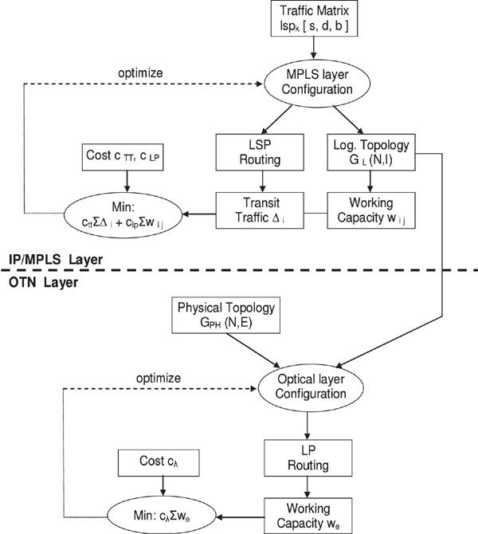
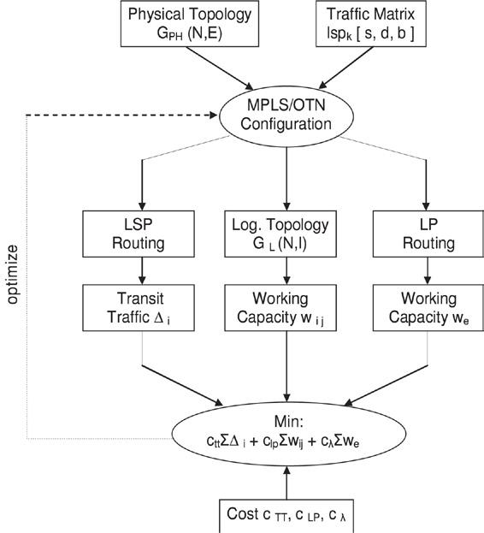
206

W. Bigos et al. / Optical Switching and Networking 3 (2006) 202–218

(a) Sequential conﬁguration method (the overlay model). (b) Integrated conﬁguration method (the peer model).

Fig. 3. Sequential vs. integrated approach to the MPLS over OTN conﬁguration. (trafﬁc matrix — set of K LSPs; each LSP has associated (s)ource,
(d)estination point and (b)andwidth; GPH⁽N, E ) — graph representing the physical network topology of N vertices (nodes) and E edges (physical
links); G_{L}(N, I ) — graph representing the logical topology of N nodes and I logical links; wi, j — capacity per node pair in the MPLS layer,
measured in the number of lightpaths installed between the node pair i – j; ∆_{i}— transit trafﬁc processed by node i ; we — capacity per link in the
optical layer, measured in the number of wavelengths used on physical link e to carry lightpaths; c_{LP}— the lightpath cost; cλ — the wavelength
cost; c_{TT}— the transit trafﬁc cost.)

probability of a given routing approach under dynamic
trafﬁc conditions. As being adapted to dynamic
environments, they are based on fast heuristics
and do not explicitly account for the amount of
network resources used to implement a particular
routing scenario. Our objective is to implement the
concepts of sequential and integrated routing as
network optimization problems and to compare the
use of network resources achieved with both methods.
Network conﬁguration according to the sequential
and integrated approaches has been studied separately
in [14–17] and [18,19] using different ILP formulations.
However, no comparative analysis of both approaches
has been provided in the literature showing their relative
importance to the resources usage.
The considered network resources subject to
optimization include:
– In the MPLS layer:
• Amount of packet processing in routers which
is proportional to the volume of the transit
trafﬁc at each router (i.e. neither originating nor
terminating in a router); by minimizing it we
improve the router throughput and minimize the
packet queuing delay.
• Number of IP/optical interfaces in routers which
constitute a signiﬁcant part of the conﬁguration
cost;
– In the optical layer:
• Number of wavelengths and amount of wavelength-
switching equipment used to route a given set of
lightpaths in the physical topology.
With the sequential approach to network conﬁgura-
tion, as presented in Fig. 3(a), the optimization problem
consists of two sub-problems. First sub-problem takes
as an input a trafﬁc matrix in terms of the LSPs to be
routed in the network and returns as a result the set of
lightpaths to be established in the optical layer (i.e. the
logical topology) and the routing of the LSPs over the
logical topology. Thus, only a part of the MPLS over
OTN conﬁguration is solved by ﬁrst sub-problem and
the optimization function takes as an objective minimiz-
ing only the IP/MPLS layer resources, i.e. the total num-
ber of lightpaths between all node pairs ∑₍i,j )^{w}(i,j )
and the total transit trafﬁc ∑_{i}∆_{i}processed by routers.
Second sub-problem takes the set of lightpaths to be
established on physical links and the physical network
topology as input parameters and returns the routing
of lightpaths in the physical topology optimizing only

W. Bigos et al. / Optical Switching and Networking 3 (2006) 202–218

207

resources of the optical layer, i.e. the total number of
wavelengths ∑_{e}we used to route the lightpaths in the
physical topology. The lightpath cost cLP, the wave-
length link cost cλ and the transit trafﬁc cost cTT are
included into the optimization procedure to account for
the total conﬁguration cost of the network. Note, how-
ever, that such decomposition is approximate or inexact.
Solving the sub-problems in sequence and combining
the solutions may not result in the optimal solution for
the fully integrated problem. On the other hand, with
the integrated approach, as depicted in Fig. 3(b), there
is only one optimization problem implemented which
provides a full MPLS over OTN design in one step. The
optimization function used to control the conﬁguration
process explicitly accounts for the resource usage both
in the MPLS and the optical layer. The global optimiza-
tion of network resources is thus possible with the inte-
grated approach. Nevertheless, achieving an absolutely
optimal solution of such a problem may be hard as the
computational complexity of the algorithm solving the
network conﬁguration problem in a combined fashion is
high.

4. Problem formulation

We consider the following network design problem.
Given the offered trafﬁc matrix (in terms of static LSP
connections), the physical network topology and a set
of constraints on logical and physical link capacities,
we search for an MPLS over OTN conﬁguration which
(i) provides 100% restorability against the considered
failure scenarios and (ii) minimizes the total resource
usage in both network layers. A cost model is included
into the optimization procedure which represents the
monetary cost of various network components. Thereby,
by minimizing the amount of network resources the cost
of a given network conﬁguration is also optimized. We
use integer linear programming (ILP) as an optimization
technique and formulate the problem using linear
models. The problem solution provides a complete
speciﬁcation to the logical topology design and routing
of working and protection paths both in the MPLS and
the optical layer together with the resource usage at the
minimal cost.
We make the following assumptions in our study:
(1) The trafﬁc matrix is symmetric and the lightpaths
are bidirectional. Two lightpaths from a pair are
routed over the same physical route but in opposite
directions.
(2) The optical layer has an opaque conﬁguration with
photonic OXCs (i.e. which switch wavelengths op-
tically) surrounded by WDM transponders perform-

ing OEO conversion. Transponders perform sig-
nal regeneration and adaptation functions including
wavelength conversion.
(3) As the optical layer supports wavelength conver-
sion, the wavelength continuity constraint is not
considered (under which a lightpath is assigned the
same wavelength on all links on its route). This as-
sumption reduces the problem in terms of ILP vari-
ables and constraints and makes it more computa-
tionally tractable.

4.1. Survivability implementation

Algorithms for the MPLS over OTN design using
the sequential conﬁguration approach combined with
various options for the survivability implementation are
presented in Fig. 4(a)–(d). Each algorithm consists of
four planning processes (steps): two for the network
design with working paths, respectively, in the MPLS
and the optical layer (steps I and III), and two others
for the network conﬁguration with protection paths
(steps II and IV). Each part is implemented as a
separate optimization problem using a distinct ILP
formulation. The planning process for the computation
of working LSPs and lightpaths (i.e. steps I and III
in each algorithm) is analogous to the one presented
in Fig. 3(a). Next, the routing of protection paths is
determined for the set of pre-computed working paths
and spare capacity is allocated. With the single-layer
survivability (see Fig. 4(a)), the spare capacity planning
is done only in the MPLS layer (in step II). The
planning process takes as the inputs the considered
failure scenarios and the routing of working LSPs
computed in step I. Then, the routing of protection
LSPs is computed taking into account the constraints
for protection routing in the MPLS layer (see below).
The optimization function aims at minimizing the total
transit trafﬁc ∑_{i}∆_{i}and the spare capacity ∑
(i, j)^{s}(i, j)
consisting of the lightpaths carrying protection LSPs.
With the multilayer survivability implementation (see
Fig. 4(b)–(d)), the spare capacity planning is done both
in the MPLS and the optical layer with the objective
to minimize the resources of each layer. Contrary to
the single-layer survivability, only multi-hop LSPs are
subject to the protection LSP routing in step II; single-
hop LSPs are protected at the lightpath level. With
the “double protection” method (Fig. 4(b)), both the
lightpaths carrying working and protection LSPs are
protected in the optical layer. With the “LSP spare
unprotected” option (Fig. 4(c)), working and protection
LSPs are routed over two disjoint sets of lightpaths
(sets G L1 and GL2) and only the lightpaths carrying

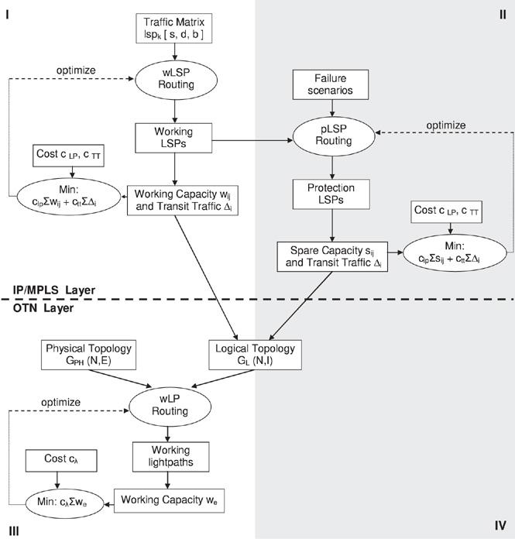
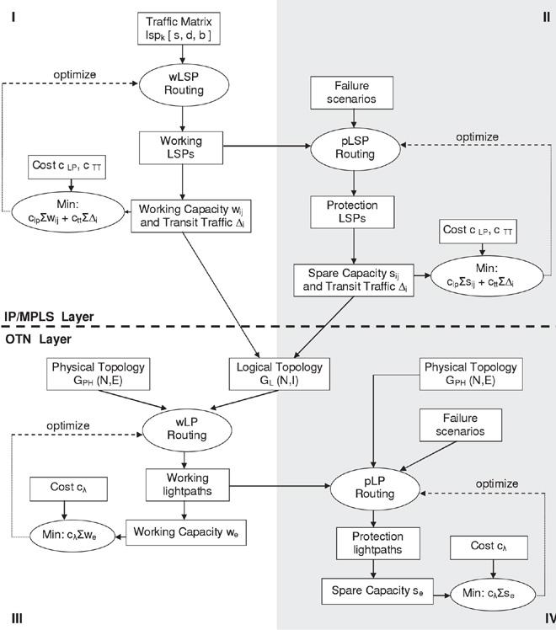
208

W. Bigos et al. / Optical Switching and Networking 3 (2006) 202–218

(a) Single layer survivability.

(b) Multilayer survivability with the double protection.

Fig. 4. Algorithms for the MPLS over OTN design using the sequential approach with various options for the survivability implementation. (s_{sd}
— spare capacity per node pair in the MPLS layer, measured in the number of lightpaths carrying protection LSPs (pLSP) between the node pair
s-d; ∆n — transit trafﬁc processed by node n; we — working capacity per link in the optical layer, measured in the number of wavelengths used
on physical link e to carry working lightpaths (wLP); se — spare capacity in the optical layer, measured in the number of wavelengths used on
physical link e to carry protection lightpaths (pLP). The other symbols have the meaning as speciﬁed in Fig. 3.)

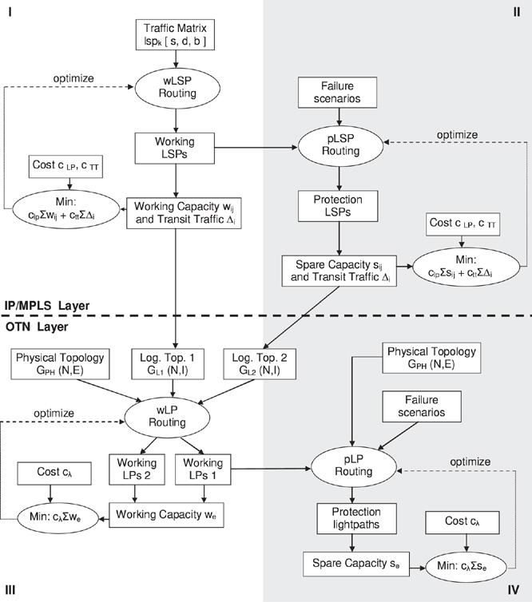
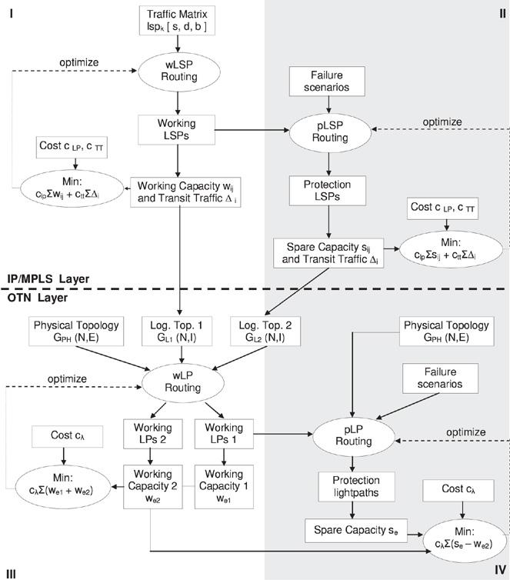
W. Bigos et al. / Optical Switching and Networking 3 (2006) 202–218

(c) Multilayer survivability with the “LSP spare unprotected” option.

(d) Multilayer survivability with the interlayer BRS.

Fig. 4. (continued)

209

210

W. Bigos et al. / Optical Switching and Networking 3 (2006) 202–218

working LSPs (from G_{L}1) have protection lightpaths;
the lightpaths carrying protection LSPs (from GL2) are
not protected. With the “interlayer BRS” (Fig. 4(d)),
not only are the lightpaths carrying protection LSPs
unprotected but they also share the wavelengths with the
protection lightpaths to optimize further the wavelength
use (i.e. spare capacity s_{e}is shared with the working
capacity we2 supporting the lightpaths which carry
protection LSPs).
Next, the planning process was repeated but
using the integrated conﬁguration approach where
the routing of working LSPs and the corresponding
lightpaths (i.e. steps I, III) was implemented as a
single optimization problem according to the scheme
presented in Fig. 3(b). The same methodology was then
used for protection LSPs and the lightpaths carrying
protection LSPs (steps II and III). Note, however, that
to combine the routing of working and protection LSPs
and lightpaths (i.e. steps I–II and III–IV) we use the
sequential approach only, i.e. routing of protection
paths is determined for the set of pre-computed
working paths. The results from computing working and
protection paths jointly are reported in [20], showing
8%–12% savings in spare capacity than if the paths are
computed separately; however, this is at the increase in
the optimization problem complexity.
The following rules are deﬁned for the protection
routing, i.e. how to route protection paths, so that all
the considered failure scenarios are supported:
– For the single-layer survivability:
• Each working LSP (wLSP) has a protection LSP
(pLSP); corresponding working and protection
LSPs are node- and link-disjoint both in the logical
and physical topology.
– For the multilayer survivability:

And for the “interlayer BRS”:
• Lightpaths transiting an OXC and LSPs transiting the
co-located router are protected on different physical
links; this prevents the failed entities from competing
for the same spare resources in case of an OXC
failure.

4.2. Cost model

By including the cost of various network elements
into the optimization procedure we optimize the
network conﬁguration cost which depends on the
number and type of established communication
channels. In this study we do not deal with the
investments for the initial network deployment which
include the cost of laying/leasing ﬁbers and the cost of
WDM line systems (without transponders), i.e. WDM
(de)multiplexers and optical ampliﬁers. As has been
stated in the problem formulation, the initial network
topology determining these costs is given to the problem
as an input parameter.
The following cost components are included in the
optimization procedure: the cost of IP/optical interface
cards in routers cP IP, the cost of OXC ports cP OXC
and the cost of optical transponders cTR. The costs
of the router and OXC equipment are incorporated,
respectively, into the IP/optical interface cost cP IP
and the OXC port cost cP OXC . Additional cost c_{TT}
is associated with the amount of the transit trafﬁc
processed by routers as a penalty for diminishing the
packet processing capability of a router which could
be otherwise used by the originating/terminating trafﬁc.
The cost c_{TT}is speciﬁed by the cP IP cost per trafﬁc
unit:
cP IP

• Each multi-hop working LSP has a protection LSP;
corresponding working and protection LSPs are
c_{TT}=
C
Ч transit trafﬁc
(1)

link- and node-disjoint in the logical topology.
• With the “double protection” method each
lightpath has a protection lightpath; with the “LSP
spare unprotected” and “interlayer BRS” method
where C denotes the IP/optical interface card rate.
We take as a reference cost the cost of one
transponder. The other elements’ costs are referenced
to this cost as follows:

only the lightpaths carrying working LSPs have
corresponding protection lightpaths. Respective
cP IP:cP OXC:cTR = 8:0.5:1.
(2)

working and protection lightpaths are link- and
node-disjoint in the physical topology.
Additional requirement for the “LSP spare unprotected”
and “interlayer BRS” methods:
• Corresponding working and protection LSPs are
node-disjoint in the physical topology; this prevents
a working LSP and its protection LSP from failing
simultaneously in case of an OXC failure.
This ratio represents the current prices of the elements
(year 2005) for 10 Gbps IP/optical interfaces and
transponders, 256 Ч 256 port photonic OXCs and
200 Gbps routers.
The total cost of a network conﬁguration is a sum
of the transit trafﬁc cost and the cost of individual
circuits: lightpaths and wavelength links, as depicted in
Fig. 5. It is assumed that each wavelength link requires 2
transponders and 2 OXC ports (i.e. 1 transponder and 1

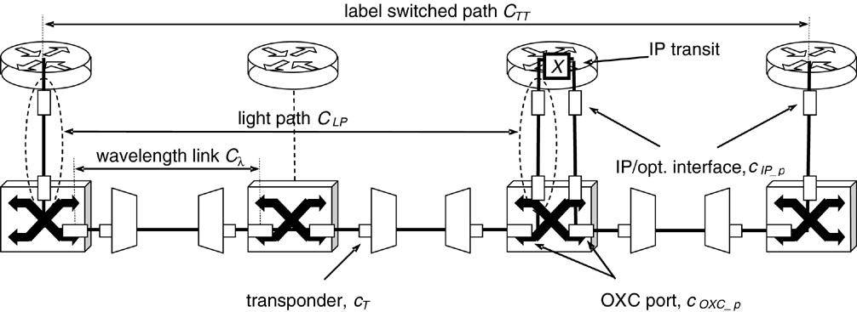
W. Bigos et al. / Optical Switching and Networking 3 (2006) 202–218

Fig. 5. Example of the MPLS over OTN conﬁguration combined with the cost of network elements.

211

OXC port for each termination point) and each lightpath
(protection and working) requires 2 IP/optical interface
cards and 2 OXC ports. Thus, the cost components
c_{LP}and cλ presented in schemes Fig. 4(a)–(d) are as
follows: c_{LP}= 2(cP IP⁺cP OXC⁾, cλ = 2(cP OXC⁺
cTR⁾.
4.3. ILP formulation

The ILPs are deﬁned using the node-arc formulation,
where network nodes are indexed by subscripts and
edges are speciﬁed by an (x, y) node-name pair:
• s and d denote source and destination nodes of an
LSP,
• i and j denote originating and terminating nodes in
a lightpath,
• q denotes a q-th lightpath between the (i, j ) pair,
• m and n denote endpoints of a physical link.
Inputs:

N ex [lp] for each lightpath in LP, the set of nodes
to be excluded from its route to respect the
protection routing constraints. Note that in
general not only protection but also working
lightpaths are subject to protection routing,
in particular, to provide disjointness between
(corresponding) working and protection LSPs
in the physical topology with the single-layer
survivability.
P_{N}ЧN physical topology matrix, where the element
p(m,n)⁼p(n,m)⁼1 if there exists a physical
link between nodes m and n; otherwise
p(m,n)⁼p(n,m)⁼0, (i.e. physical links are
bidirectional). It is assumed that there are no
multiple links between node pairs.
C capacity of a lightpath.
Q max. number of lightpaths of a given status
(i.e. working, protection) to be set up between
a given node pair. It is assumed that q ∈ {1, 2}.

N
set of nodes; each element represents a generic
network node being a combination of a router
and the co-located OXC.
T

W
max. number of IP/optical interfaces in a
router.
max. number of wavelengths on a physical

LSP set of K LSPs to be routed in the network; each
link.

element lsp_{k}represents an indivisible trafﬁc
ﬂow to be routed on a single LSP and has
associated a triple: {s(lsp_{k}), d (lsp_{k}), b(lsp_{k})}
denoting respectively its source, destination
cTT
c_{LP}
cλ
cost of the transit trafﬁc per trafﬁc unit.
cost of setting up a lightpath.
cost of allocating a wavelength.

LP
node and bandwidth.
set of lightpaths determining the logical topol-
ogy; each element lp has associated a triple:
{i (lp), j (lp), q (lp)} denoting respectively its
originating node, terminating node and the
multiple.
Variables:
(1) Logical topology variables wβ(i,j),q,pβ(i, j),q = 1
if there exists a q-th lightpath from node i to node
j carrying, respectively, working and protection
LSPs; 0 otherwise.

p LSP set of LSPs to be protected; a subset of LSP.
p LP set of lightpaths to be protected; a subset of LP.
N ex[lsp] for each lsp in p LSP, the set of nodes to be
excluded from the route of its protection LSP
to respect the protection routing constraints.
(2) LSP routing variables wδ₍lsp_{i}, j),q,pδ₍lsp_{i}, j),q⁼1 if,
respectively, working/protection LSP lsp is routed
on the q-th lightpath from node i to node j ; 0
otherwise.
(3) Lightpath routing variables:

212

W. Bigos et al. / Optical Switching and Networking 3 (2006) 202–218

(a) With the sequential conﬁguration method: (2) Constraints for the LSP routing:
wλ^{l p}(m,n),pλ^{l p}(m,n)⁼1 if, respectively, the
working/protection lightpath lp is routed on the ∑ ∑ wδ₍lsp_{i}, j),q − ∑ ∑ wδ^{lsp}( j,i ),q
physical link (m, n ); 0 otherwise. j: j6=i q j : j6=i q
₁, if i = s(lsp)

(b) With the integrated conﬁguration method:
wλ⁽(^{i}m,j,n^{),})^{q}, if a q-th working lightpath from node
i to node j is routed on the physical link (m, n);
0 otherwise. Note that as protection lightpaths
=

−1, if i = d(lsp)
0, otherwise
∀lsp ∈ LSP, i ∈ N

(9)

are routed using the sequential method only, no
protection routing variable is deﬁned here.
∑
j : j6=i,
j6∈N ex[lsp]
∑_{p}δ₍lsp_{i}, j),q − ∑ ∑_{p}δ^{lsp}( j,i),q
q j q

₁, if i = s(lsp)

Optimization function:
The objective is to limit the total network resource
usage by minimizing costs of the transit trafﬁc and
capacity allocation (working + spare) in both network
=

−1, if i = d(lsp)
0, otherwise
∀lsp ∈ p LSP, i 6∈ N ex[lsp]

(10)

layers:
Minimize: c_{TT}· ∑ ∆_{n}+ c_{LP}· ∑_{(w}(i,j )⁺s(i,j))
wδ | lsp  (i,j),q+pδlsp(i,j),q≤1
∀lsp ∈ p L S P, (i, j) ∈ N², q

(11)

n
+ cλ·∑_{(w}(m,n)⁺s(m,n))
(m,n)
where:
(i, j)

(3)
∑ b req(lsp) · wδ₍lsp_{i}, j),q ≤ wβ(i, j),q · C
lsp
∀(i, j) ∈ N², q
∑ b req(lsp) · pδ₍lsp_{i}, j),q ≤ pβ(i,j ),q·C
lsp

(12)

∆_{n}= ∑ b req(lsp) · ∑ ∑(wδ^{lsp}(i,n),q⁺pδ₍lsp_{i},n),q⁾
lsp i q
∀(i, j) ∈ N², q .
(13)

− ∑
lsp:d(lsp)=n
b req(lsp)
(4)

(3) Constraints for the lightpath routing:

w(i, j)⁺s(i,j )⁼∑ wβ(i, j),q⁺∑_{p}β(i,j ),q.
q q

– With the sequential conﬁguration approach:
(5)

– With the sequential conﬁguration approach:

w(m,n) + s(m,n) = ∑ wλ^{l p}(m,n)⁺∑_{p}λ^{l p}(m,n).(6a)
l p l p
∑
m:m6=n,
m6∈N ex[l p]
wλ^{l p}(n,m) − ∑ wλ^{l p}(m,n)
m

₁, if n = i(l p)

– With the integrated conﬁguration approach:
∑
=

−1, if n = j (l p)
0, otherwise

w(m,n)⁺s(m,n)⁼∑
(i, j) q
wλ⁽(^{i}m,j,n^{),})^{q}+ ∑_{p}λ^{l p}(m,n).
l p
(6b)

∑
m:m6=n,
∀l p ∈ LP; n 6∈ N ex[l p]
pλ^{l p}(n,m) − ∑_{p}λ^{l p}(m,n)
m
(14a)

The cost components c_{TT}, c_{LP}and cλ are associated as
speciﬁed in the cost model (see Section 4.2).
m6∈N ex[l p]
₁, if n = i(l p)

Constraints:

(1) Constraints for the logical topology design:
=

−1, if n = j (l p)
0, otherwise
∀l p ∈ p LP;n 6∈ N ex[l p]

(15)

∑ ∑ wβ(i, j),q + pβ(i,j),q ≤ T, ∀i ∈ N (7)
j: j 6=i q
wλ^{l p}(m,n)⁺pλ^{l p}(m,n) ≤ 1
∀l p ∈ p LP; (m, n) ∈ N²

(16a)

∑ ∑ wβ(i, j),q + pβ(i,j ),q ≤ T, ∀ j ∈ N. (8)
i:i 6=j q
∑ wλ^{l p}(m,n)⁺pλ^{l p}(m,n) ≤ W ∀(m, n) ∈ N². (17a)
l p

W. Bigos et al. / Optical Switching and Networking 3 (2006) 202–218

213

– With the integrated conﬁguration approach:

working and protection lightpaths. Eqs. (17a) and
(17b) make the number of lightpaths routed on the

∑
m:m6=n,
m6∈N ex[l p]
wλ⁽(^{i}n,,^{j}m^{),})^{q}− ∑ wλ⁽(^{i}m,j,n^{),})^{q}
m
physical link (m, n ) not to exceed the total number
of wavelengths. Binary constraint (18) ensures that the

wβ(i, j),q,if n = i
variables take only 0/1 values.

=

−wβ(i, j),q,if n = j
0, otherwise
∀(i, j ) ∈ N², n 6∈ N ex[l p], q

(14b)
In a network of N nodes, E links and max. q
lightpaths per node pair supporting a trafﬁc matrix
composed of K LSPs, the size of the problem solved
with the sequential approach is ≈q · N²· K /2 in terms

wλ⁽(^{i}m,,^{j}n^{),})^{q}+ pλ^{l p}(m,n) ≤ 1 ∀(i, j), (m, n) ∈ N²,
q, p ∈ p L P : i (l p) = i, j (l p) = j, q(l p) = q
(16b)
∑ ∑ wλ⁽(^{i}m,j,),_{n})^{q}+ ∑_{p}λ^{l p}(m,n) ≤ W
(i, j) q l p
∀(m, n) ∈ N². (17b)
(4) Binary constraints:
wβ(i,j ),q,pβ(i, j),q, wδ₍lsp_{i}, j),q,pδ^{lsp}(i,j ),q, wλ^{l p}(m,n),
pλ^{l p}(m,n), wλ⁽(^{i}m,j,n^{),})^{q}∈ {0, 1} . (18)
Eq. (4) speciﬁes the transit trafﬁc at node i as a
difference between the total incoming trafﬁc and the
trafﬁc terminated at i . Eq. (5) speciﬁes the working
and spare capacity per node pair in the MPLS layer
as a sum of lightpaths carrying working and protection
LSPs between a general node pair (i, j ). Eqs. (6a) and
(6b) determine the working and spare capacity per link
in the optical layer as a sum of wavelengths carrying
working and protection lightpaths on a general link
(m, n). Eqs. (7) and (8) make the number of lightpaths
originating and terminating at node i not to exceed
T . For each LSP (working + protection), Eqs. (9)
and (10) specify the ﬂow conservation constraint at
every node on its route. Some nodes are excluded from
the routing of protection LSPs (Eq. (10)) to meet the
protection routing constraints. Eq. (11) provides logical
link-disjointness between corresponding working and
protection LSPs. Eqs. (12) and (13) make the total
trafﬁc carried by all LSPs on the lightpath (i, j ), q
not to exceed the lightpath capacity. For each OXC
and lightpath (working + protection), Eqs. (14a), (14b)
and (15) specify the ﬂow conservation constraint at
the lightpath level. This states that the number of
lightpaths incoming to and outgoing from a node
is equal. With the integrated approach the logical
topology and lightpath routing are determined jointly
(cf. Eq. (14b)), whereas with the sequential approach
lightpath routing is determined for the set of pre-
computed lightpaths (cf. Eq. (14a)). Eqs. (16a) and
(16b) provide link-disjointness between corresponding
of variables, whereas the same problem solved with the
integrated approach is ≈q · N²· (K /2 + E).

5. Numerical results

The problems speciﬁed above were implemented
and solved using the CPLEX 9.0 optimization package.
All experiments were carried out on an HP Alpha
workstation with a 1 GHz CPU and 2 GB RAM running
Tru64 UNIX OS. The system parameters were set as
follows: C = 10 Gbps, W = 32, Q = 2, T = 2Q·(N −
1). The number of wavelengths per link W , IP/optical
interface cards per node T , the router throughput
and the OXC size were overprovisioned in a way
that no resources shortage constraints were affecting
the conﬁguration process, but only the optimization
function used.

5.1. Computational efﬁciency

The logical topology design problem belongs to
the class of NP-hard problems for which no efﬁcient
(i.e. polynomial time) algorithms are known. It is
therefore essential to verify the computational limits of
the proposed ILP-based solution method. The problem
complexity measure was the execution time of the
algorithms as a function of the problem size (in terms
of the number of nodes and trafﬁc demands). Solution
times of the network conﬁguration based on the
sequential and integrated approaches were compared
for different problem sizes and for the computation
of working vs. protection paths. The solver was set
to stop any optimization within a maximum time
limit of 5 h and a 3% solution optimality gap was
assumed. If in any case the solver stopped without
full termination, the solution quality achieved so far
has been reported in terms of the optimality gap.
The results are summarized in Table 1. The obtained
results show that by setting reasonable optimality
gaps and run-time limits on ILP algorithms quite
good solutions to the speciﬁed problems can be
obtained even without a full termination, at least for
moderate size networks (up to 15 nodes with fully

214

Table 1

W. Bigos et al. / Optical Switching and Networking 3 (2006) 202–218

Running times of the ILP algorithms for different problem sizes (values in brackets denote achieved optimality gaps)

Computation of working paths
Computation of protection paths

Conﬁg.
Approach
Problem size (N)

8 10

12

14

15
Conﬁg.
Approach
Problem size (N )

8 10

12

14

15

Sequential 12.4 s
(0.77%)
70 s
(0.72%)
951 s
(0.5%)
1403 s
(0.41%)
3632 s
(0.83%)
Sequential 70 s
(optimal)
1011 s
(0.44%)
2542 s
(0.66%)
17093 s
(0.32%)
Unsolved

Integrated 101 s
(1.62%)

Table 2
542 s
(1.66%)
1211 s
(1.18%)
18 000 s
(2.8%)
Unsolved Integrated 550 s
(0.34%)
8856 s
(1.12%)
18 000 s
(1.76%)
Unsolved –

Network resource usage and the conﬁguration cost for different survivability options

Single-layer survivability
Multilayer survivability
Double protection

LSP spare unprotected

Interlayer BRS

(a) 126 LSPs; LSP bandwidth = 1, 2, 3 Gbps; total trafﬁc = 300 Gbps
Transit trafﬁc 124 Gbps 94 Gbps

92 Gbps

92 Gbps

# of lightpaths
# of wavelengths
Total cost
Optical layer cost
56 (33)
140
1471 (26%)
420 (19%)
82 (18)
172
1985
516
66 (21)
138
1626 (18%)
414 (25%)
66 (21)
108 (4)
1537 (22%)
324 (37%)

(b) 126 LSPs; LSP bandwidth = 2, 4, 6 Gbps; total trafﬁc = 600 Gbps
Transit trafﬁc 262.5 Gbps 100 Gbps

97.5 Gbps

97.5 Gbps

# of lightpaths
# of wavelengths
Total cost
Optical layer cost
143 (79)
329
3628 (5%)
987 (1.5%)
160 (16)
334
3802
1002
148 (20)
297
3485 (8%)
891 (11%)
148 (20)
267 (7)
3395 (11%)
801 (20%)

(c) 126 LSPs; LSP bandwidth = 3, 6, 9 Gbps; total trafﬁc = 900 Gbps
Transit trafﬁc 107.5 Gbps 52.5 Gbps

52.5 Gbps

52.5 Gbps

# of lightpaths
# of wavelengths
Total cost
Optical layer cost
208 (105)
596
5410
1788
226 (10)
505
5399 (0.2%)
1515 (15%)
216 (10)
490
5184 (4%)
1470 (18%)
216 (10)
480 (0)
5154 (5%)
1440 (20%)

The number of lightpaths in brackets (row 2) denotes the lightpaths carrying protection LSPs. The number of wavelengths in brackets (row 3)
denotes extra wavelengths needed to accommodate protection LSPs with the “interlayer BRS”. The cost percentage denotes the cost savings with
respect to the most expensive method.

meshed trafﬁc matrices). Thereby, the proposed ILP-
based solution method can be used as a practical
design tool, for example, for nationwide backbone
networks (which typically consist of 10–15 nodes in
European countries) without resorting to heuristics.
The solution times of the optimization based on the
integrated approach is about one order of magnitude
longer than when using the sequential approach and
the difference in solution times for the two methods
increases as the problem size grows. This was expected,
as in a network of N nodes, E links and max. q
lightpaths per node pair the complexity of the integrated
approach increases by ∼q · E · N²faster in terms of
variables and constraints, as compared to the sequential
approach. As a consequence, for the biggest solved

problems the solution could only be obtained using the
sequential approach. Solution times for the computation
of protection paths were longer due to additional
constraints for protection routing: (11) and (15).

5.2. Analysis of results

For the survivability implementation we used a test
network targeted to a nationwide coverage, presented in
Fig. 6. The network has a bi-connected mesh topology
consisting of 12 nodes and 24 physical links. There are
10 nodes distributing the nationwide trafﬁc (1–10) and
2 gateways providing the Internet access (11, 12). The
trafﬁc matrix is population-weighted and consists of 56
bidirectional, symmetric trafﬁc demands or 126 LSPs

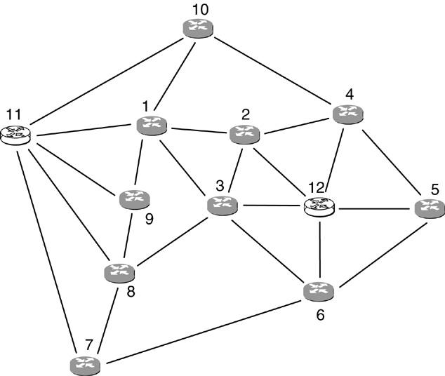
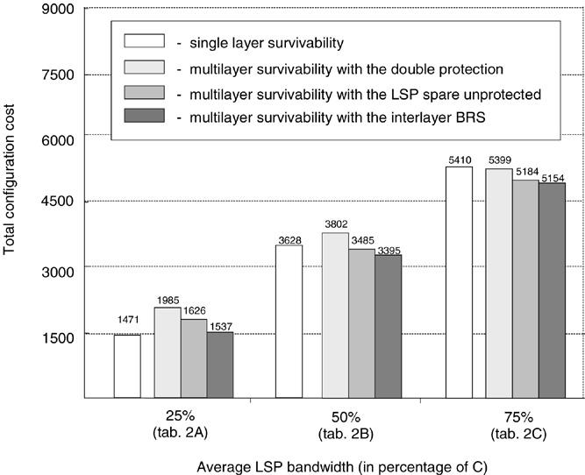
W. Bigos et al. / Optical Switching and Networking 3 (2006) 202–218

Fig. 6. 12-node test network.

Fig. 7. Cost comparison of different survivability options. C denotes the lightpath capacity, equal to 10 Gbps.

215

(as some demands consist of more than 1 LSP). To
check for different values of the LSP bandwidth and the
total offered trafﬁc, three groups of tests were carried
out: for the average LSP bandwidth equal to 2.5, 5.0
and 7.5 Gbps. The results obtained with the sequential
conﬁguration method are summarized in Table 2(a)–(c)
and Fig. 7.

5.2.1. Single-layer vs. multilayer survivability analysis
The main difference between the single-layer (SL)
and the multilayer (ML) survivability is due to the fact
that with the ML survivability only multi-hop LSPs are
subject to protection routing and hence consume the
MPLS spare capacity, whereas with the SL survivability

both single- and multi-hop LSPs require spare resources
of the MPLS layer. This results in a higher number
of lightpaths carrying protection LSPs (see values in
brackets in Table 2(a)–(c)) and higher transit trafﬁc
obtained with the SL survivability. However, with the
ML survivability protection lightpaths are added, so the
total number of lightpaths is higher in this scenario. This
in turn affects the total conﬁguration cost as lightpaths
are the most expensive network resources.
For low-bandwidth LSPs, the SL survivability is the
cheapest option, as depicted in Table 2(a) and Fig. 7.
Low-bandwidth LSPs tend to be routed in multiple
logical hops as they are groomed in intermediate routers
to better ﬁll the lightpath capacity. As a result, there

216

Table 3

W. Bigos et al. / Optical Switching and Networking 3 (2006) 202–218

Sequential vs. integrated conﬁguration method for different survivability options with the average LSP bandwidth equal to 50% of the lightpath
capacity (as in Table 2(b))

Survivability
option
Sequential

Transit trafﬁc
(Gbps)

# of
light-
paths

# of
wave-
lengths
Integrated

Transit trafﬁc
(Gbps)

# of
light-
paths

# of
wave-
lengths
Reduction

Wavelengths Optical layer
cost (%)

Total
cost
(%)

No survivability 77.5
SL survivability 262.5
Double protection 100
64
143
160
108
329
334
77.5
262.5
100
64
143
160
93
303
304
15
26
30
14
8
9
3
2
2

LSP spare
unprotected
97.5
148
297
97.5
148
279
18
6
1.5

Interlayer BRS 97.5
148
267
97.5
148
251
16
6
1.4

exist relatively many multi-hop LSPs which are subject
to protection routing with the ML survivability and
more lightpaths are added after the protection LSP
routing (21), despite a small total number of lightpaths.
This makes the ML survivability the most expensive
option for low-bandwidth LSPs.
This relation changes for high-bandwidth LSPs,
close to the lightpath capacity (Table 2(c)). High-
bandwidth LSPs tend to be routed in single logical hops,
i.e. on direct lightpaths, to minimize the transit trafﬁc
(note the small amount of the transit trafﬁc, as compared
with the other trafﬁc scenarios). Therefore, there exist
relatively few multi-hop LSPs which are subject to
the protection routing with the ML survivability. As
a result, much fewer lightpaths are added after the
protection LSP routing (10), as compared with the SL
survivability (105). This tendency and further savings
in the wavelength use brought by the ML survivability
(respectively 15%, 18% and 20% with different SCA
methods) make this option the cheapest in this trafﬁc
scenario. The difference in the wavelength usage is due
to the fact that with the SL survivability working and
protection LSPs have disjoint routes in both network
layers, whereas with the ML survivability working and
protection lightpaths are disjoint only in the optical
layer. As a result, lightpaths take longer routes with the
SL survivability.
We found the ML survivability with the “double
protection” the most expensive option for the low- and
medium-size LSPs (see Table 2(a), (b)).

5.2.2. Multilayer survivability — analysis of different
SCA methods
Decreasing cost trends from “double protection”
to “LSP spare unprotected” to “interlayer BRS” was
expected as the spare resources of the MPLS layer are
supported more and more efﬁciently by the optical layer.
The lower total number of lightpaths achieved with

the “LSP spare unprotected” method over the “double
protection” is due to the fact that the lightpaths carrying
protection LSPs (respectively 21, 20 and 10 with
different trafﬁc scenarios) are not protected. Savings
in the wavelength usage stem from the fact that fewer
lightpaths in total are routed in the physical topology
(respectively 66 vs. 82, 148 vs. 160 and 216 vs. 226 for
different trafﬁc scenarios). Further savings are brought
by the “interlayer BRS” method due to wavelength
sharing among lightpaths carrying protection LSPs
and protection lightpaths. One can see that most of
the wavelengths used by the protection lightpaths are
reused by the lightpaths carrying protection LSPs. Only,
respectively, 4, 7, and 0 extra wavelengths are needed to
accommodate protection LSPs within the optical layer
for different trafﬁc scenarios. This gives the reuse factor
equal respectively to 84%, 80% and 100%.

5.2.3. Sequential vs. integrated conﬁguration method
As a next step we tested the impact of the
sequential vs. integrated conﬁguration method on
network resource usage and conﬁguration cost. The
results produced by the two methods for different
survivability options and the trafﬁc matrix consisting
of medium-size LSPs are summarized in Table 3
and Fig. 8. In all cases we observed a gain in the
wavelength usage brought by the integrated method
over the sequential one, while the MPLS layer resources
(i.e. no. of established lightpaths and the transit trafﬁc)
were exactly the same. The difference is due to the fact
that with the sequential approach the logical topology
design and the lightpath routing are separated and the
lightpaths are conﬁgured without the knowledge of
the physical layer resources. As a consequence, the
resulting logical topology is sub-optimal with respect
to the wavelength usage and some lightpaths require
longer physical routes. This effect is avoided with the
integrated method where both processes are conﬁgured

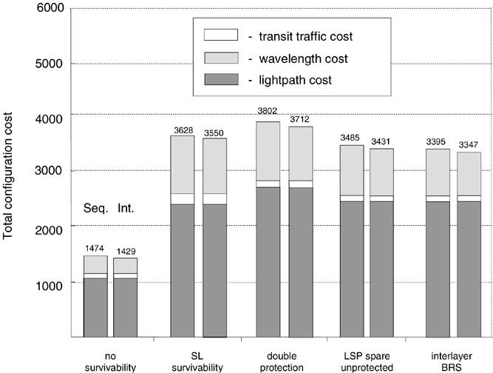
W. Bigos et al. / Optical Switching and Networking 3 (2006) 202–218

Fig. 8. Cost comparison of the sequential (Seq.) vs. integrated (Int.) conﬁguration method.

217

jointly. This allows the lightpaths to be optimally
designed also in terms of the wavelength use (in
fact, about 40% of lightpaths had different termination
points when conﬁgured with the integrated method as
compared to the sequential one). The gain from using
the integrated approach is higher for the conﬁguration
with working paths only (i.e. without survivability), as
with the survivability implementation the wavelength
routing is subject additionally to the protection routing
constraints which tighten the solution space and leave
less room for optimization.
As the number of lightpaths remains the same for
both approaches which constitute about 70% of the total
conﬁguration cost (cf. Fig. 8), the contribution of the
integrated approach to the total cost savings is only
1.4%–3%. This rather small improvement brings us to
the conclusion that in this particular case (i.e. with the
ratio between the lightpath and the wavelength cost
equal to ∼5) the use of the sequential approach may
be preferable, especially if taking into account much
lower times spent on optimization as compared with the
integrated method (cf. Table 1).

6. Conclusions

This study explored some design principles of
MPLS over OTN architectures employing wavelength
switching and targeted to a nationwide coverage. We
used the ILP optimization combined with a cost model
to dimension the network with the minimal resource
usage and conﬁguration cost. The obtained results are
based on a cost model with actual technology pricing
and representative trafﬁc matrices.

We have presented two approaches to the MPLS over
OTN design and investigated various options for the
survivability implementation. The comparative analysis
between the single- and multilayer survivability shows
the impact of the LSP bandwidth on network resource
usage and conﬁguration cost. For high-bandwidth
LSPs, close to the lightpath capacity, the multilayer
survivability is up to 5% more cost-effective in terms
of the total cost and up to 20% in terms of the optical
layer cost. In contrast, for the low-bandwidth LSPs it
is the single-layer survivability which brings up to 26%
of total cost savings. For the multilayer survivability we
have demonstrated that by mapping efﬁciently the spare
capacity of the MPLS layer onto the resources of the
optical layer one can achieve up to 22% savings in the
total conﬁguration cost and up to 37% in the optical
layer cost. We have found the integrated conﬁguration
method to be up to 9% more cost-efﬁcient in terms
of the wavelength use as compared with the sequential
one; however, this is at the increase in the optimization
problem complexity. On the other hand, as there is
no effect of the conﬁguration approach on the transit
trafﬁc and the number of lightpaths, the total cost
reduction brought by the integrated approach is no more
than 3%. This rather small cost improvement reveals
the usefulness of the sequential approach based on
decomposition to improve the optimization time and,
consequently, to increase the size of problems to be
handled, at the expense of a relatively small drop in the
solution quality.
Finally, we show that by setting reasonable
optimality gaps and run-time limits on the ILP
algorithms quite good solutions to the speciﬁed
problems can be obtained even without a full

218

W. Bigos et al. / Optical Switching and Networking 3 (2006) 202–218

termination. Thereby, the proposed ILP-based solution
method can serve as a practical design tool, at least for
moderate size networks, without resorting to heuristics.

References

[1] I. Chlamtac, A. Ganz, G. Karmi, Lightpath communication:
an approach to high bandwidth optical WANs, IEEE Trans.
Commun. 7 (1992) 1171–1182.
[2] P. Demeester, et al., Resilience in multilayer networks, IEEE
Commun. Mag. 8 (1999) 70–75.
[3] C. Assi, et al., On the merit of MPLS protection/restoration in
IP over WDM networks, in: IEEE Globecom’01 Conf., 2001,
pp. 65–69.
[4] S. De Maesschalck, et al., Intelligent optical networking for
multilayer survivability, IEEE Commun. Mag. 1 (2002) 42–49.
[5] L. Lei, A. Liu, Y. Ji, A joint resilience scheme with interlayer
backup resource sharing in IP over WDM networks, IEEE
Commun. Mag. 1 (2004) 78–84.
[6] S. Phillips, N. Reinold, R. Doverspike, Network studies in
IP/Optical layer restoration, in: Optical Fiber Conference,
OFC’02, 2002, pp. 425–427.
[7] B.T. Doshi, S. Dravida, P. Harshavardhana, O. Hauser, Y. Wang,
Optical network design and restoration, Bell Labs Tech. J. 1
(1999) 58–84.
[8] B. Van Caenegem, W. Van Parys, F. De Turck, P. Demeester,
Dimensioning of survivable WDM networks, IEEE JSAC 7
(1998) 1146–1157.
[9] L. Sahasrabuddhe, S. Ramamurthy, B. Mukherjee, Fault
management in IP over WDM networks: WDM protection vs.
IP restoration, IEEE JSAC 1 (2002) 21–33.
[10] B. Rajagopalan, et al., IP over optical networks: architectural
aspects, IEEE Commun. Mag. 9 (2000) 94–102.

[11] Q. Zheng, G. Mohan, An efﬁcient dynamic protection scheme
in integrated IP/WDM networks, in: IEEE ICC’03, 2003, pp.
1494–1498.
[12] M. Kodialam, T.V. Lakshman, Integrated dynamic IP and
wavelength routing in IP over WDM networks, in: IEEE
Infocom’01 Conf., 2001, pp. 358–366.
[13] J. Comellas, R. Martinez, J. Prat, V. Sales, G. Junyent, Integrated
IP/WDM routing in GMPLS-based optical networks, IEEE
Netw. 17 (2) (2003) 22–27.
[14] R. Ramaswami, K.N. Sivarajan, Design of logical topologies
for wavelength-routed optical networks, IEEE JSAC 6 (1996)
840–851.
[15] B. Mukherjee, D. Banerjee, S. Ramamurthy, A. Mukherjee,
Some principles in designing a wide-area WDM optical
network, IEEE/ACM Trans. Netw. 5 (1996) 684–695.
[16] R. Dutta, G.N. Rouskas, Design of logical topologies for
wavelength routed networks, in: K. Sivalingam, S. Subramanian
(Eds.), Optical WDM Networks: Principles and Practice, Kluwer
Publishers, 2000, pp. 79–102.
[17] R.M. Krishnaswamy, K.N. Sivarajan, Design of logical
topologies: a linear formulation for wavelength-routed optical
networks with no wavelength changers, IEEE/ACM Trans.
Netw. 4 (2001) 186–198.
[18] D. Banerjee, B. Mukherjee, Wavelength routed optical
networks: linear formulation, resource budgeting tradeoffs, and
a reconﬁguration study, IEEE/ACM Trans. Netw. 5 (2000)
598–607.
[19] F. Ricciato, S. Salsano, A. Belmonte, M. Listanti, Off-line
conﬁguration of a MPLS over WDM network under time-
varying offered trafﬁc, in: Proc. IEEE Infocom’02, 2002, pp.
57–65.
[20] W.D. Grover, Mesh-Based Survivable Networks. Option and
Strategies for Optical, MPLS, SONET and ATM Networking,
Prentice Hall PTR, 2004.

